fall 2024
Cse-4355/5355 Electromechanical Systems and Sensors
the university of texas at arlington


lab 3 report
Submitted toward the partial completion of the requirements for CSE 4355/5355
Under the guidance of
Prof. Jason Losh
By:
Dario Ugalde, 1001268068
Joshua Martinez, 1001374818

Introduction
A motor is a machine powered through electricity or combustion and provides motion. Rotations per minute, or RPM, were discussed during lecture and can be defined as a motor’s speed. For this lab, electrical motors are used which contain internal coils. During use, the said coil creates a magnetic field during rotation and thus introduces a back emf. This biproduct acts against the applied voltage. At a certain point, the back emf heavily impairs the input and may cause the motor to reduce speed, for example. This lab will implement two approaches meant to capture back emf. The first uses LED diodes and a phototransistor to capture an RPM measurement of an active motor for the emf conversion. The second will require a voltage halt during the motor operation to capture and understand circuit’s back emf. Although they reach the same conclusion, the first involves complex additions. Each approach has unique benefits, but in circuit design, fewer components result in cheaper products and less points of failure. Thus, the back emf approach is more common in practice and usage. This report documents our team’s results of implementing both techniques.

Steps 1 – 3: Circuit Setup
The first part of the lab involved setting up the circuit. Firstly, a permanent magnet DC (PMDC) motor variant and other components were connected to the TM4C123GXL microcontroller, which ran as an analog ADC input, CCP timer counter, and PWM on the pins PE4, PC6, and PD0 respectively. A voltage source of 10V from the bench power supply powered the side of the circuit containing the motor. It was connected to the drain of a FQP20N06L n-channel power MOSFET in parallel with a 1N5817 Schottky diode. This diode’s purpose was to reduce the voltage spike from the collapsing magnetic field the motor will create during operation and measuring. The gate of the MOSFET was connected to the microcontroller’s PWM pin through a voltage divider to prevent damage to the microcontroller.
Afterwards, the LED and phototransistor were set up for an optical RPM capture. Their placement was positioned on either side of the rotating disk attached to the motor’s shaft. It contained 32 slits which toggled the phototransistor during operation. They allowed for the motor’s speed to monitored and captured. The drawing below demonstrates the initial connections for the motor’s circuit:
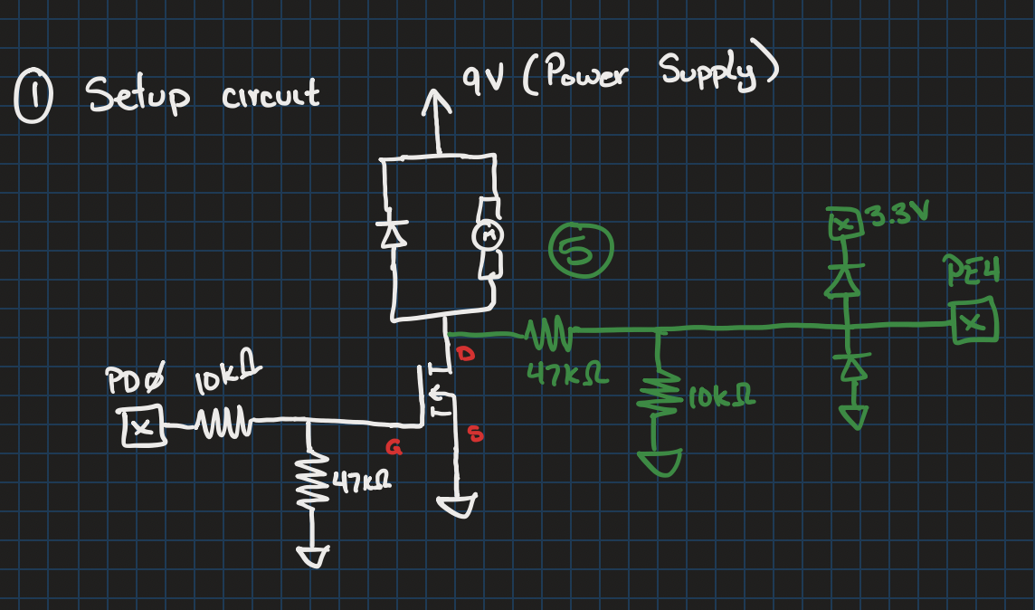
Figure 1: Drawing of LED RPM Circuit

Steps 4 – 5: Calculate Motor RPM
With the circuit completed, code was created to allow the microcontroller to process the optical input from rotating disk. The phototransistor’s lighting change incremented a counter on the CCP timer. Push buttons, SW1 and SW2, were programmed to control the motor’s PWM duty cycle, with SW1 incrementing the PWM duty cycle by 10% and SW2 decrementing it by 10%. They offered the user to vary the RPM during testing. The UART modules was used to provide user feedback of the current value of the PWM duty cycle.
An interrupt was configured to read the number counted by the CCP timer at a frequency of 1Hz. This counter value would be multiplied by 60 to convert a second into minutes. It will then be divided by 32, the total slits around the disk, to get the RPM of the motor at a given PWM duty cycle. This resulting figure was then provided for the user to spectate via an UART module. Examples of this user feedback are shown below in Figure 3.

Steps 6 – 10: Calculate RPM Via Back-EMF Voltage
The next section of the lab involved extending the code base to support RPM calculation through back EMF voltage. To capture this output, another timer was configured to capture input from the ADC pin (shown in green in Figure 1). This interrupt momentarily sets the PWM duty cycle to zero and removes any power from the power supply. The remaining momentum of the spinning motor is due to the motor’s collapsing magnetic field. At this moment, an ADC reading will be captured from the analog pin before resetting the duty cycle back to its previous value. A slight delay of 200μs is used prior to taking the ADC reading to allow the back EMF voltage to stabilize. This second timer triggers at a rate of 50Hz. With this setup, ten values could be measured representing the back EMF based on the current duty cycle. Through these measurements, a linear regression can be taken from the data to establish an equation where given a voltage, V, a speed, S, can be calculated. The equation and points used by our team can be seen below in Figure 2:
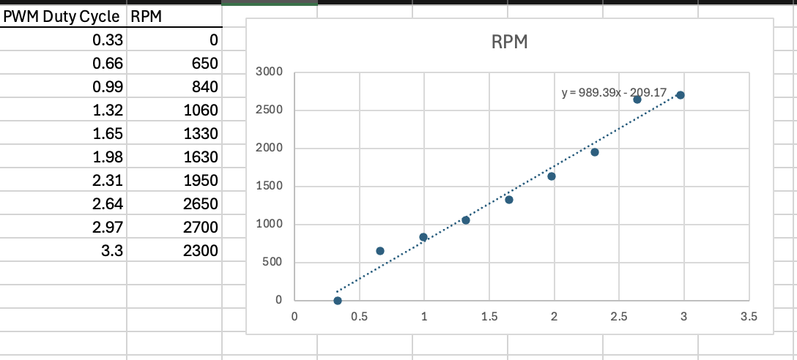
Figure 2: PWM Duty Cycle vs RPM

Conclusion

In conclusion, this lab explored two of multitudes of methods in calculating the RPM of a PMDC motor. Both these approaches accomplished the same task with slight differences. The optical method offered real-time monitoring at the cost of extra circuitry. The back EMF variant required less components and offers an estimate of the motor’s RPM. Through the lab, we verified the accuracy of the second method against the first through a conversion of the measured back EMF into RPM. Below are captures of the oscilloscope reading which demonstrate the back EMF behavior used to calculate said RPM. Also included are outputs from the UART module which exhibits our capture of the back EMF voltage, ADC capture, and back EMF and LED RPM values.

